Supplementary information

A synergistic UAV-driven deep learning and epidemic modeling framework for dynamic spatiotemporal prediction of maize leaf spot

Table S6.1 Vegetation indices derived from hyperspectral images
Name | Abbreviation | Equation | Equation
VIs for plant biophysical properties: structure, crop cover
Structural
Normalized Difference Vegetation Index | NDVI | (R₈₀₀−R₆₇₀)/(R₈₀₀+R₆₇₀) | Rouse et al. (1974)
Near−Infrared Reflectance of Vegetation | NIR_{V} | R₈₀₀(R₈₀₀−R₆₇₀)/(R₈₀₀+R₆₇₀) | Badgley et al. (2017)
Renormalized Difference Vegetation Index | RDVI | (R₈₀₀−R₆₇₀)/(R₈₀₀+R₆₇₀)^{1/2} | Roujean and Breon (1995)
Simple Ratio | SR | R₈₀₀/R₆₇₀ | Carter (1994)
Modified Red−edge Ratio | mSR | (R₇₅₀−R₄₄₅)/(R₇₀₅−R₄₄₅) | Sims and Gamon (2002)
Optimized Soil−Adjusted Vegetation Index | OSAVI | (1+0.6)(R₈₀₀−R₆₇₀)/(R₈₀₀+R₆₇₀+0.16) | Rondeaux et al. (1996)
Modified Triangular Vegetation Index 1 | MTVI1 | 1.2(1.2(R₈₀₀−R₅₅₀)−2.5(R₆₇₀−R₅₅₀)) | Haboudane et al. (2004)
Modified Triangular Vegetation Index 2 | MTVI2 |  | Haboudane et al. (2004)
Enhanced Vegetation Index | EVI | 2.5(R₈₀₀−R₆₇₀)/(R₈₀₀+6R₆₇₀−7.5R₄₀₀+1) | Huete et al. (2002)
Lichtenthaler Index | LIC₁ | (R₈₀₀−R₆₈₀)/(R₈₀₀+R₆₈₀) | Lichtenthaler et al. (1996)
VIs for plant biochemical properties: pigments, water and nitrogen
Chlorophyll
Vogelmann Indices | VOG1 | R₇₄₀/R₇₂₀ | Vogelmann et al. (1993)
Vogelmann Indices | VOG2 | (R₇₃₄−R₇₄₇)/(R₇₁₅−R₇₂₆) | Vogelmann et al. (1993)
Vogelmann Indices | VOG3 | (R₇₃₄−R₇₄₇)/(R₇₁₅+R₇₂₀) | Vogelmann et al. (1993)
Gitelson and Merzlyak Indices | GM1 | R₇₅₀/R₅₅₀ | Gitelson and Merzlyak (1996)
Gitelson and Merzlyak Indices | GM2 | R₇₅₀/R₇₀₀ | Gitelson and Merzlyak (1996)
Transformed Chlorophyll Absorption in Reflectance Index | TCARI | 3×[(R₇₀₀−R₆₇₀)−0.2×(R₇₀₀−R₅₅₀)× (R₇₀₀/R₆₇₀)] | Haboudane et al. (2002)
TCARI/OSAVI | TCARI/OSAVI | TCARI/OSAVI | Haboudane et al. (2002)
Chlorophyll Index | CI | R₇₅₀/R₇₁₀ | Zarco-Tejada et al. (2001)
Simple Ratio Pigment Index | SRPI | R₄₃₀/R₆₈₀ | Penuelas et al. (1995)
Normalized Phaeophytinization Index | NPQI | (R₄₁₅−R₄₃₅)/(R₄₁₅+R₄₃₅) | Barnes et al. (1992)
Pigment Specific  Simple Ratio for Chl a | PSSRa | R₈₀₀/R₆₈₀ | Blackburn (1998)
Pigment Specific  Simple Ratio for Chl b | PSSRb | R₈₀₀/R₆₃₅ | Blackburn (1998)
Pigment Specific Normalized Difference | PSND | (R₈₀₀−R₆₇₅)/(R₈₀₀+R₆₇₅) | Blackburn (1998)
Carotenoid
Carotenoid Reflectance  Index | CRI₅₅₀ | (1/R₅₁₀)−(1/R₅₅₀) | Gitelson et al. (2002)
Carotenoid Reflectance  Index | CRI₇₀₀ | (1/R₅₁₀)−(1/R₇₀₀) | Gitelson et al. (2003)
Modified Carotenoid Reflectance Index 550 | CRI_{550m} | (1/R₅₁₅)−(1/R₅₅₀) | Gitelson et al. (2003)
Modified Carotenoid Reflectance Index 700 | CRI_{700m} | (1/R₅₁₅)−(1/R₇₀₀) | Gitelson et al. (2003)
Near−Infrared Carotenoid Reflectance Index 550 | RCRI₅₅₀ | (1/R₅₁₀)−(1/R₅₅₀)R₇₇₀ | Gitelson et al. (2006)
Near−Infrared Carotenoid Reflectance Index 700 | RCRI₇₀₀ | (1/R₅₁₀)−(1/R₇₀₀)R₇₇₀ | Gitelson et al. (2006)
Simple Ratio Carotenoids | CAR | R₆₉₅/R₇₆₀ | Hernández-Clemente et al. (2012)
Lichtenthaler Index | LIC₃ | R₄₄₀/R₇₄₀ | Lichtenthaler et al. (1996)
Anthocyanins
Visible Atmospherically Resistant Index | VARI | (R₅₅₅−R₆₅₀)/(R₅₅₅+R₆₅₀−R₄₇₅) | Gitelson et al. (2001)
Visible Atmospherically Resistant Index 2 | VARI2 | (R₅₆₀₋R₆₆₈)/(R₅₆₀+R₆₆₈−R₄₇₅) | Gitelson et al. (2001)
Anthocyanin Reflectance Index | ARI | 1/R₅₅₀−1/R₇₀₀ | Gitelson et al. (2001)
Modified Anthocyanin Reflectance Index | ARIm | R₈₀₀(1/R₅₅₀−1/R₇₀₀) | Gitelson et al. (2006)
Pigments: Carotenoid and chlorophyll
Normalized Pigments Index | NPCI | (R₆₈₀−R₄₃₀)/(R₆₈₀+R₄₃₀) | Penuelas et al. (1995)
Structure−Intensive Pigment Index | SIPI | (R₈₀₀−R₄₄₅)/(R₈₀₀+R₆₈₀) | Penuelas et al. (1995)
Plant Senescence Reflectance Index | PSRI | (R₆₈₀−R₅₀₀)/R₇₅₀ | Merzlyak et al. (1999)
Blue Index | B | R₄₅₀/R₄₉₀ | Calderón et al. (2013)
Greenness Index | G | R₅₇₀/R₆₇₀ | Calderón et al. (2013)
Redness Index | R | R₇₀₀/R₆₇₀ | Gitelson et al. (2000)
Blue/green Indices | BGI1 | R₄₀₀/R₅₅₀ | Zarco-Tejada et al. (2005)
Blue/green Indices | BGI2 | R₄₅₀/R₅₅₀ | Zarco-Tejada et al. (2005)
Blue Fraction | BF1 | R₄₀₀/R₄₁₀ | Zarco-Tejada et al. (2018)
Blue Fraction | BF2 | R₄₀₀/R₄₂₀ | Zarco-Tejada et al. (2018)
Blue Fraction | BF3 | R₄₀₀/R₄₃₀ | Zarco-Tejada et al. (2018)
Blue Fraction | BF4 | R₄₀₀/R₄₄₀ | Zarco-Tejada et al. (2018)
Blue Fraction | BF5 | R₄₀₀/R₄₅₀ | Zarco-Tejada et al. (2018)
Blue/Red Indices | BRI1 | R₄₉₀/R₆₉₀ | Zarco-Tejada et al. (2012)
Blue/Red Indices | BRI2 | R₄₅₀/R₆₉₀ | Zarco-Tejada et al. (2012)
Relative Greenness Index | RGI | R₆₉₀/R₅₅₀ | Zarco-Tejada et al. (2005)
Ratio Analysis of Reflectance Spectra | RARS | R₇₄₆/R₅₁₃ | Chappelle et al. (1992)
Pigment Specific  Simple Ratio for Cars | PSSRc | R₈₀₀/R₄₇₀ | Blackburn (1998)
Datt Cab Cx+c Index | DCabxc | R₆₇₂/(R₅₅₀×3R₇₀₈) | Datt (1998)
Datt NIR Cab Cx+c Index | DNCabxc | R₈₆₀/(R₅₅₀×R₇₀₈) | Datt (1998)
Nitrogen
Double−peak Canopy Nitrogen Index | DCNI | (R₇₂₀−R₇₀₀)/(R₇₀₀₋R₆₇₀)/(R₇₂₀−R₆₇₀+0.03) | Chen et al. (2010)
Structure and chlorophyll
Triangular Vegetation Index | TVI | 0.5(120(R₇₅₀−R₅₅₀)−200(R₆₇₀−R₅₅₀)) | Broge and Leblanc (2001)
VIs for plant physiological properties
Xanthophyll and photosynthetic efficiency
Photochemical Reflectance Indices | PRI | (R₅₇₀−R₅₃₁)/(R₅₇₀+R₅₃₁) | Gamon et al. (1992)
Photochemical Reflectance Index (515) | PRI₅₁₅ | (R₅₁₅−R₅₃₁)/(R₅₁₅+R₅₃₁) | Hernandez-Clemente et al. (2011)
Photochemical Reflectance Index (512) | PRI_{m1} | (R₅₁₂−R₅₃₁)/(R₅₁₂+R₅₃₁) | Hernandez-Clemente et al. (2011)
Photochemical Reflectance Index (600) | PRI_{m2} | (R₆₀₀−R₅₃₁)/(R₆₀₀+R₅₃₁) | Gamon et al. (1992)
Photochemical Reflectance Index (670) | PRI_{m3} | (R₆₇₀−R₅₃₁)/(R₆₇₀+R₅₃₁) | Gamon et al. (1992)
Photochemical Reflectance Index (670 and 570) | PRI_{m4} | (R₅₇₀−R₅₃₁−R₆₇₀)/(R₅₇₀+R₅₃₁+R₆₇₀) | Hernandez-Clemente et al. (2011)
Normalized Photosynthetic Reflectance Index | PRI_{n} | PRI₅₇₀/[RDVI×(R₇₀₀/R₆₇₀)] | Zarco-Tejada et al. (2013)
Carotenoid/Chlorophyll Ratio Index | PRI×CI | (R₅₇₀−R₅₃₀)/(R₅₇₀+R₅₃₀)×((R₇₆₀/R₇₀₀)−1) | Garrity et al. (2011)
Chlorophyll fluorescence
Reflectance Curvature Index | CUR | $$(R_{675}R_{690})/R_{683}^{2}$$ | Zarco-Tejada et al. (2000)
Stresses
Health Index  (534,698,704) | HI | (R₅₃₄−R₆₉₈)/(R₅₃₄+R₆₉₈)−0.5×R₇₀₄ | Mahlein et al. (2013)
Lichtenthaler | LIC₂ | R₄₄₀/R₆₉₀ | Lichtenthaler (1996)
Carter Indices | CTRI | R₆₉₅/R₄₂₀ | Carter (1994)
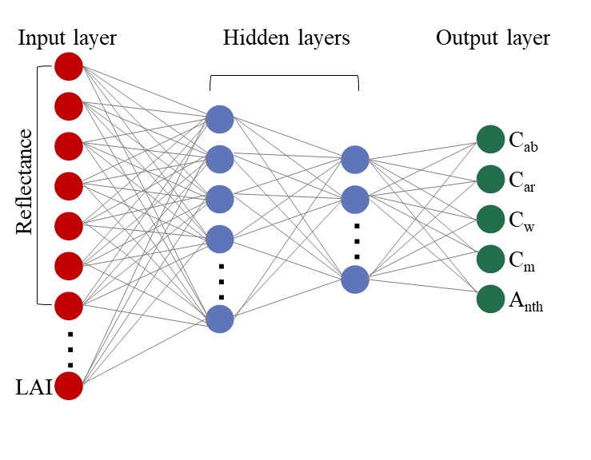

Fig. S6.1. Architecture of the multilayer perceptron (MLP) regression model used to estimate key biophysical parameters, including chlorophyll content (C_{ab}), carotenoid content (C_{ar}), equivalent water thickness (C_{w}), dry matter content (C_{m}), and anthocyanin content (A_{nth}).
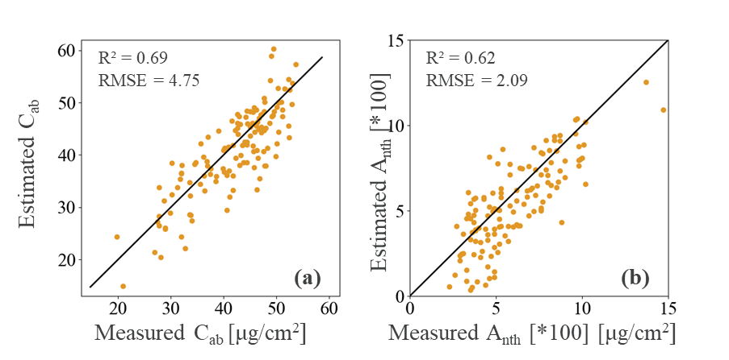

Fig. S6.2 Correlation of measured vs. PROSAIL estimated C_{ab} and A_{nth}. A total of 132 samples from site A (12 plots × 11 times) were evaluated.

Table S6.2 Prediction report of different models on 2021 test set
Metric | Class | Epidemic model | RS-DL |  |  | RS-DeepSpread model
Metric | Class | Epidemic model | MLP | LSTM | GRU | RS-DeepSpread model
Precision | Early | 63.18% | 81.28% | 77.62% | 79.72% | 88.06%
Precision | Mild | 67.06% | 77.38% | 76.73% | 79.67% | 83.01%
Precision | Moderate | 38.46% | 66.67% | 66.67% | 69.70% | 87.10%
Precision | Severe | 0.00% | 100.00% | 100.00% | 100.00% | 100.00%
Precision | weighted avg | 63.21% | 78.43% | 76.48% | 79.05% | 85.59%
Recall | Early | 85.00% | 75.00% | 74.09% | 76.82% | 80.45%
Recall | Mild | 48.10% | 82.28% | 79.32% | 82.70% | 90.72%
Recall | Moderate | 29.41% | 70.59% | 70.59% | 67.65% | 79.41%
Recall | Severe | 0.00% | 100.00% | 100.00% | 100.00% | 100.00%
Recall | weighted avg | 63.21% | 78.25% | 76.42% | 79.07% | 85.37%
F1-score | Early | 72.48% | 78.01% | 75.81% | 78.24% | 84.09%
F1-score | Mild | 56.02% | 79.75% | 78.01% | 81.16% | 86.69%
F1-score | Moderate | 33.33% | 68.57% | 68.57% | 68.66% | 83.08%
F1-score | Severe | 0.00% | 100.00% | 100.00% | 100.00% | 100.00%
F1-score | weighted avg | 61.70% | 78.24% | 76.42% | 79.03% | 85.30%
Overall accuracy |  | 63.21% | 78.25% | 76.42% | 79.07% | 85.37%

Table S6.3 Prediction report of different models on 2023 test set
Metric | Class | Epidemic model | RS-DL |  |  | RS-DeepSpread model
Metric | Class | Epidemic model | MLP | LSTM | GRU | RS-DeepSpread model
Precision | Early | 40.00% | 100.00% | 100.00% | 100.00% | 100.00%
Precision | Mild | 85.33% | 81.94% | 83.78% | 84.42% | 91.55%
Precision | Moderate | 91.89% | 76.74% | 78.57% | 87.18% | 91.11%
Precision | Severe | 66.67% | 100.00% | 50.00% | 50.00% | 100.00%
Precision | weighted avg | 86.19% | 80.90% | 81.39% | 84.98% | 91.81%
Recall | Early | 66.67% | 66.67% | 66.67% | 66.67% | 66.67%
Recall | Mild | 92.75% | 85.51% | 89.86% | 94.20% | 94.20%
Recall | Moderate | 75.56% | 73.33% | 73.33% | 75.56% | 91.11%
Recall | Severe | 66.67% | 100.00% | 33.33% | 33.33% | 66.67%
Recall | weighted avg | 85.00% | 80.83% | 81.67% | 85.00% | 91.67%
F1-score | Early | 50.00% | 80.00% | 80.00% | 80.00% | 80.00%
F1-score | Mild | 88.89% | 83.69% | 86.71% | 89.04% | 92.86%
F1-score | Moderate | 82.93% | 75.00% | 75.86% | 80.95% | 91.11%
F1-score | Severe | 66.67% | 100.00% | 40.00% | 40.00% | 80.00%
F1-score | weighted avg | 85.13% | 80.75% | 81.31% | 84.56% | 91.56%
Overall accuracy |  | 85.00% | 80.83% | 81.67% | 85.00% | 91.67%
Note: weighted avg refers to the support-weighted average across all labels. Bold values indicate the best performance, while underlined values represent the second-best.

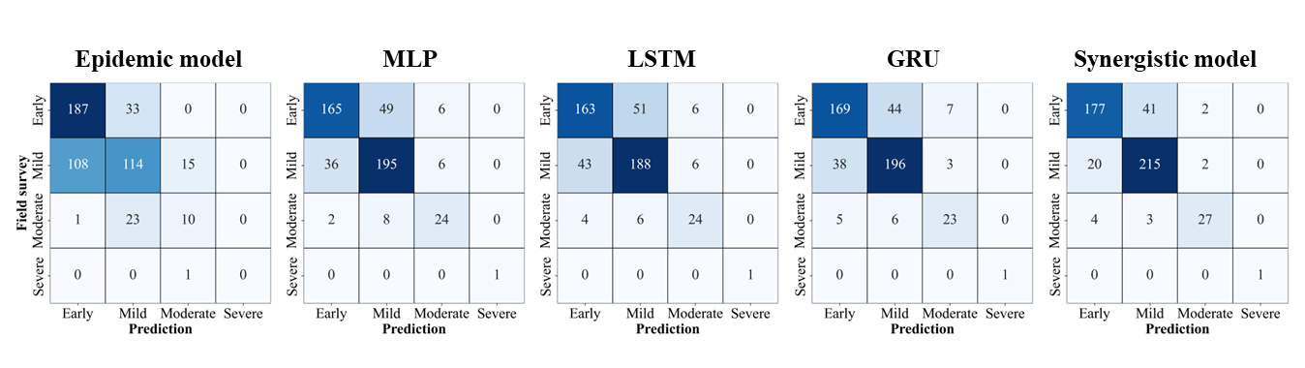

Fig.S6.3. Confusion matrices for different models on 2021 test set
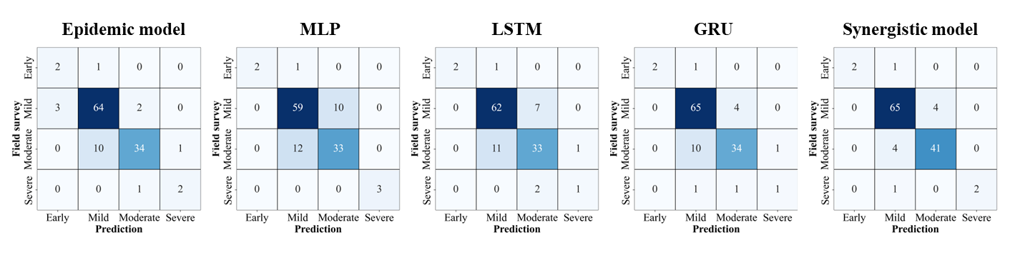

Fig.S6.4. Confusion matrices for different models on 2023 test set

Reference
Badgley, G., Field, C.B., Berry, J.A. (2017). Canopy near-infrared reflectance and terrestrial photosynthesis. Science Advances, 3, e1602244
Barnes, J.D., Balaguer, L., Manrique, E., Elvira, S., Davison, A.W. (1992). A reappraisal of the use of DMSO for the extraction and determination of chlorophylls a and b in lichens and higher plants. Environmental and Experimental Botany, 32, 85-100
Blackburn, G.A. (1998). Spectral indices for estimating photosynthetic pigment concentrations: A test using senescent tree leaves. International Journal of Remote Sensing, 19, 657-675
Broge, N.H., Leblanc, E. (2001). Comparing prediction power and stability of broadband and hyperspectral vegetation indices for estimation of green leaf area index and canopy chlorophyll density. Remote Sensing of Environment, 76, 156-172
Calderón, R., Navas-Cortés, J.A., Lucena, C., Zarco-Tejada, P.J. (2013). High-resolution airborne hyperspectral and thermal imagery for early detection of Verticillium wilt of olive using fluorescence, temperature and narrow-band spectral indices. Remote Sensing of Environment, 139, 231-245
Carter, G.A. (1994). Ratios of leaf reflectances in narrow wavebands as indicators of plant stress. Remote Sensing, 15, 697-703
Chappelle, E.W., Kim, M.S., McMurtrey, J.E. (1992). Ratio analysis of reflectance spectra (RARS): An algorithm for the remote estimation of the concentrations of chlorophyll A, chlorophyll B, and carotenoids in soybean leaves. Remote Sensing of Environment, 39, 239-247
Chen, P., Haboudane, D., Tremblay, N., Wang, J., Vigneault, P., Li, B. (2010). New spectral indicator assessing the efficiency of crop nitrogen treatment in corn and wheat. Remote Sensing of Environment, 114, 1987-1997
Datt, B. (1998). Remote sensing of chlorophyll a, chlorophyll b, chlorophyll a+b, and total carotenoid content in eucalyptus leaves. Remote Sensing of Environment, 66, 111-121
Gamon, J.A., Peñuelas, J., Field, C.B. (1992). A narrow-waveband spectral index that tracks diurnal changes in photosynthetic efficiency. Remote Sensing of Environment, 41, 35-44
Garrity, S.R., Bohrer, G., Maurer, K.D., Mueller, K.L., Vogel, C.S., Curtis, P.S. (2011). A comparison of multiple phenology data sources for estimating seasonal transitions in deciduous forest carbon exchange. Agricultural and Forest Meteorology, 151, 1741-1752
Gitelson, A., Keydan, G., Merzlyak, M., Gitelson, C. (2006). Three-band model for noninvasive estimation of chlorophyll carotenoids and anthocyanin contents in higher plant leaves. Geophysical Research Letters, 33, L11402
Gitelson, A., Merzlyak, M., Zur, Y., Stark, R., Gritz, U. (2001). Non-destructive and remote sensing techniques for estimation of vegetation status. Papers in Natural Resources, 1, 273
Gitelson, A.A., Gritz, Y., Merzlyak, M.N. (2003). Relationships between leaf chlorophyll content and spectral reflectance and algorithms for non-destructive chlorophyll assessment in higher plant leaves. Journal of Plant Physiology, 160, 271-282
Gitelson, A.A., Merzlyak, M.N. (1996). Signature analysis of leaf reflectance spectra: algorithm development for remote sensing of chlorophyll. Journal of Plant Physiology, 148, 494-500
Gitelson, A.A., Yacobi, Y.Z., Schalles, J.F., Rundquist, D.C., Han, L., Stark, R., Etzion, D. (2000). Remote estimation of phytoplankton density in productive waters. Ergebnisse der Limnologie, 121-136
Gitelson, A.A., Zur, Y., Chivkunova, O.B., Merzlyak, M.N. (2002). Assessing carotenoid content in plant leaves with reflectance spectroscopy. Photochemistry and Photobiology, 75, 272-281
Haboudane, D., Miller, J.R., Pattey, E., Zarco-Tejada, P.J., Strachan, I.B. (2004). Hyperspectral vegetation indices and novel algorithms for predicting green LAI of crop canopies: Modeling and validation in the context of precision agriculture. Remote Sensing of Environment, 90, 337-352
Haboudane, D., Miller, J.R., Tremblay, N., Zarco-Tejada, P.J., Dextraze, L. (2002). Integrated narrow-band vegetation indices for prediction of crop chlorophyll content for application to precision agriculture. Remote Sensing of Environment, 81, 416-426
Hernandez-Clemente, R., Navarro-Cerrillo, R.M., Suarez, L., Morales, F., Zarco-Tejada, P.J. (2011). Assessing structural effects on PRI for stress detection in conifer forests. Remote Sensing of Environment, 115, 2360-2375
Hernández-Clemente, R., Navarro-Cerrillo, R.M., Zarco-Tejada, P.J. (2012). Carotenoid content estimation in a heterogeneous conifer forest using narrow-band indices and PROSPECT+DART simulations. Remote Sensing of Environment, 127, 298-315
Huete, A., Didan, K., Miura, T., Rodriguez, E.P., Gao, X., Ferreira, L.G. (2002). Overview of the radiometric and biophysical performance of the MODIS vegetation indices. Remote Sensing of Environment, 83, 195-213
Lichtenthaler, H.K. (1996). Vegetation Stress: an Introduction to the Stress Concept in Plants. Journal of Plant Physiology, 148, 4-14
Lichtenthaler, H.K., Lang, M., Sowinska, M., Heisel, F., Miehe, J.A. (1996). Detection of vegetation stress via a new high resolution fluorescence imaging system. Journal of Plant Physiology, 148, 599-612
Mahlein, A.K., Rumpf, T., Welke, P., Dehne, H.W., Plümer, L., Steiner, U., Oerke, E.C. (2013). Development of spectral indices for detecting and identifying plant diseases. Remote Sensing of Environment, 128, 21-30
Merzlyak, M.N., Gitelson, A.A., Chivkunova, O.B., Rakitin, V.Y. (1999). Non-destructive optical detection of pigment changes during leaf senescence and fruit ripening. Physiologia Plantarum, 106, 135-141
Penuelas, J., Baret, F., Filella, I. (1995). Semi-empirical indices to assess carotenoids/chlorophyll a ratio from leaf spectral reflectance. Photosynthetica, 31, 221-230
Rondeaux, G., Steven, M., Baret, F. (1996). Optimization of soil-adjusted vegetation indices. Remote Sensing of Environment, 55, 95-107
Roujean, J.-L., Breon, F.-M. (1995). Estimating PAR absorbed by vegetation from bidirectional reflectance measurements. Remote Sensing of Environment, 51, 375-384
Rouse, J.W., Haas, R.H., Schell, J.A., Deering, D.W. (1974). Monitoring vegetation systems in the Great Plains with ERTS. NASA Special Publication, 351, 309
Sims, D.A., Gamon, J.A. (2002). Relationships between leaf pigment content and spectral reflectance across a wide range of species, leaf structures and developmental stages. Remote Sensing of Environment, 81, 337-354
Vogelmann, J.E., Rock, B.N., Moss, D.M. (1993). Red edge spectral measurements from sugar maple leaves. International Journal of Remote Sensing, 14, 1563-1575
Zarco-Tejada, P.J., Berjon, A., Lopez-Lozano, R., Miller, J.R., Martin, P., Cachorro, V., Gonzalez, M.R., de Frutos, A. (2005). Assessing vineyard condition with hyperspectral indices: Leaf and canopy reflectance simulation in a row-structured discontinuous canopy. Remote Sensing of Environment, 99, 271-287
Zarco-Tejada, P.J., Camino, C., Beck, P.S.A., Calderon, R., Hornero, A., Hernandez-Clemente, R., Kattenborn, T., Montes-Borrego, M., Susca, L., Morelli, M., Gonzalez-Dugo, V., North, P.R.J., Landa, B.B., Boscia, D., Saponari, M., Navas-Cortes, J.A. (2018). Previsual symptoms of Xylella fastidiosa infection revealed in spectral plant-trait alterations. Nat Plants, 4, 432-439
Zarco-Tejada, P.J., Gonzalez-Dugo, V., Berni, J.A.J. (2012). Fluorescence, temperature and narrow-band indices acquired from a UAV platform for water stress detection using a micro-hyperspectral imager and a thermal camera. Remote Sensing of Environment, 117, 322-337
Zarco-Tejada, P.J., González-Dugo, V., Williams, L.E., Suárez, L., Berni, J.A.J., Goldhamer, D., Fereres, E. (2013). A PRI-based water stress index combining structural and chlorophyll effects: Assessment using diurnal narrow-band airborne imagery and the CWSI thermal index. Remote Sensing of Environment, 138, 38-50
Zarco-Tejada, P.J., Miller, J.R., Mohammed, G.H., Noland, T.L., Sampson, P.H. (2000). Chlorophyll fluorescence effects on vegetation apparent reflectance: II. Laboratory and airborne canopy-level measurements with hyperspectral data. Remote Sensing of Environment, 74, 596-608
Zarco-Tejada, P.J., Miller, J.R., Mohammed, G.H., Noland, T.L., Sampson, P.H. (2001). Estimation of chlorophyll fluorescence under natural illumination from hyperspectral data. International Journal of Applied Earth Observation Geoinformation, 3, 321-327

